

Areesha Raheel
55039
BSIT-6
Problem Solving-III
Lab 5

Lab Tasks:
1. Write a C++ program that generates all possible subsets of a given set of integers.
Example Input:
Set = {1, 2, 3}
Expected Output
{}
{1}
{2}
{3}
{1 2}
{1 3}
{2 3}
{1 2 3}
Code:
#include <iostream>
using namespace std;

void generateSubsets(int set[], int n, int index, int subset[], int size) {
// Print subset
cout << "{ ";
for (int i = 0; i < size; i++)
cout << subset[i] << " ";
cout << "}" << endl;

for (int i = index; i < n; i++) {
subset[size] = set[i];
generateSubsets(set, n, i + 1, subset, size + 1);
}
}

int main() {
int set[] = {1, 2, 3};
int subset[10];

generateSubsets(set, 3, 0, subset, 0);
return 0;
}
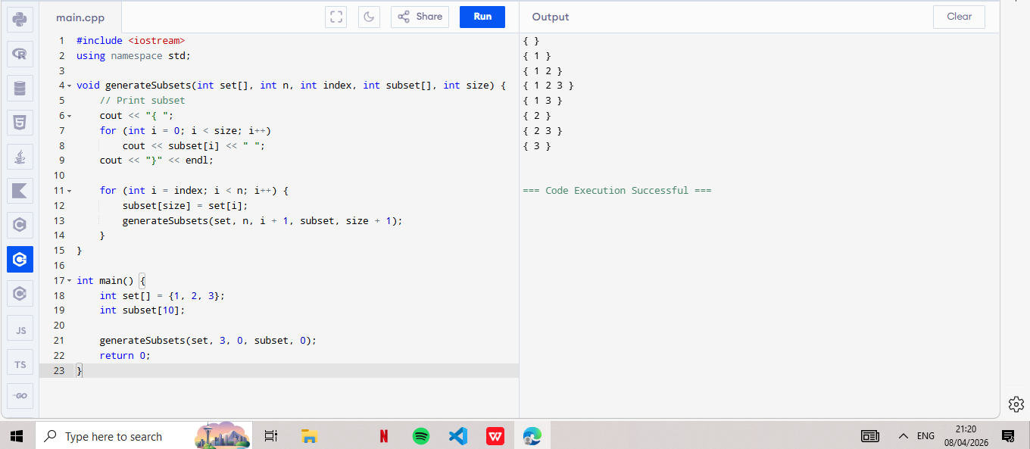
2. Write a C++ program that checks whether a subset exists whose sum equals a given target value.
Example Input:
Set = {3, 4, 5, 6}
Target = 9
Output:
Subset with given sum exists.
Code:
#include <iostream>
using namespace std;

bool subsetExists(int set[], int n, int index, int sum, int target) {
if (sum == target)
return true;

if (index == n || sum > target)
return false;

return subsetExists(set, n, index + 1, sum + set[index], target) ||
subsetExists(set, n, index + 1, sum, target);
}

int main() {
int set[] = {3, 4, 5, 6};
int target = 9;

if (subsetExists(set, 4, 0, 0, target))
cout << "Subset with given sum exists\n";
else
cout << "No subset found\n";

return 0;
}
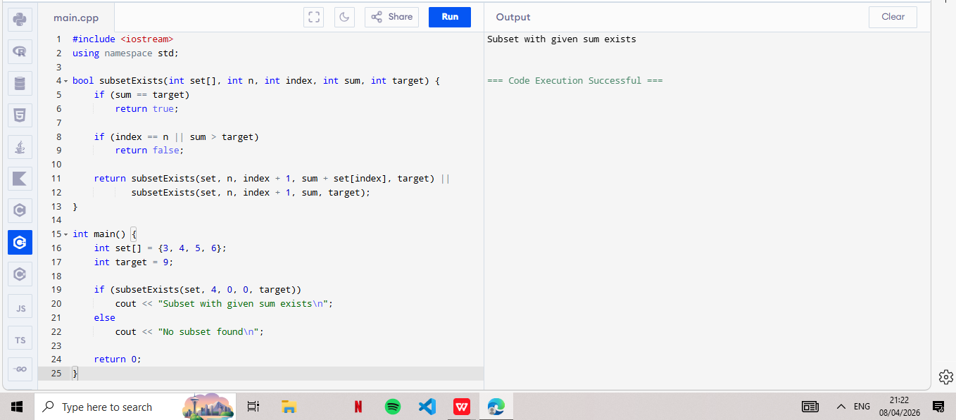
3. Modify the program so that it prints one subset whose sum equals the target value.
Example Output
Subset found: 4 5
Code:
#include <iostream>
using namespace std;

bool findOneSubset(int set[], int subset[], int n, int size, int sum, int target, int index) {
if (sum == target) {
cout << "Subset found: ";
for (int i = 0; i < size; i++)
cout << subset[i] << " ";
cout << endl;
return true;
}

if (index == n || sum > target)
return false;

subset[size] = set[index];
if (findOneSubset(set, subset, n, size + 1, sum + set[index], target, index + 1))
return true;

return findOneSubset(set, subset, n, size, sum, target, index + 1);
}

int main() {
int set[] = {3, 4, 5, 6};
int subset[10];
int target = 9;

findOneSubset(set, subset, 4, 0, 0, target, 0);

return 0;
}
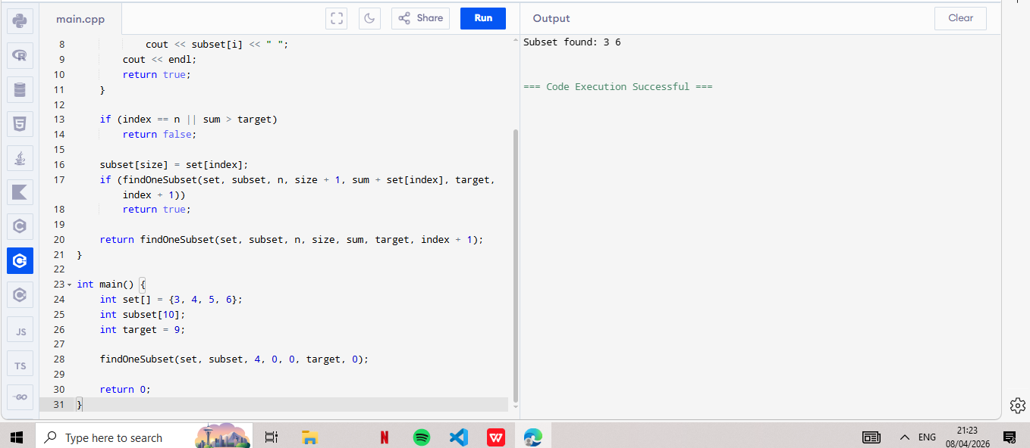
4. Write a program that prints all subsets whose sum equals the target value.
Example Input:
Set = {5, 10, 12, 13, 15, 18}
Target = 30
Output:
Subset: 12 18
Subset: 5 10 15
Subset: 5 12 13
Code:
#include <iostream>
using namespace std;

void printAllSubsets(int set[], int subset[], int n, int size, int sum, int target, int index) {
if (sum == target) {
cout << "Subset: ";
for (int i = 0; i < size; i++)
cout << subset[i] << " ";
cout << endl;
return;
}

if (index == n || sum > target)
return;

// Include
subset[size] = set[index];
printAllSubsets(set, subset, n, size + 1, sum + set[index], target, index + 1);

// Exclude
printAllSubsets(set, subset, n, size, sum, target, index + 1);
}

int main() {
int set[] = {5,10,12,13,15,18};
int subset[10];
int target = 30;

printAllSubsets(set, subset, 6, 0, 0, target, 0);

return 0;
}
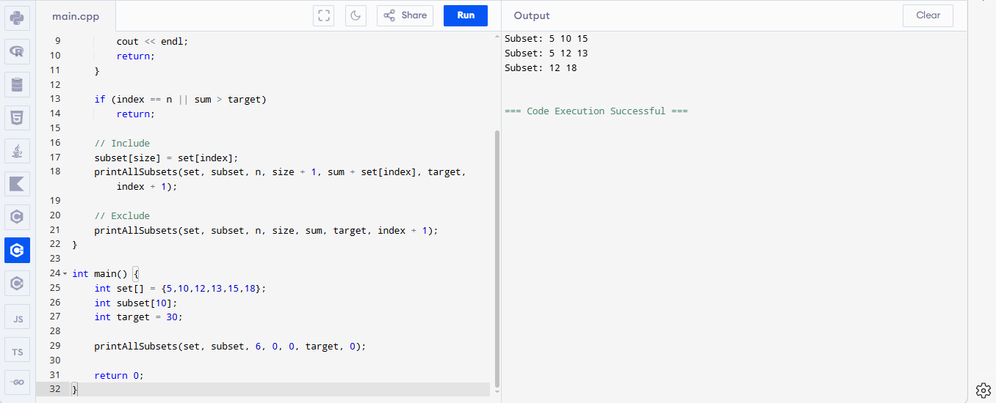
5. Write a program that counts the number of subsets whose sum equals the target value.
Example Input:
Set = {3, 4, 5, 6}
Target = 9
Output:
Total subsets = 2
Because:
{3,6}
{4,5}
Code:
#include <iostream>
using namespace std;

int countSubsets(int set[], int n, int index, int sum, int target) {
if (sum == target)
return 1;

if (index == n || sum > target)
return 0;

return countSubsets(set, n, index + 1, sum + set[index], target) +
countSubsets(set, n, index + 1, sum, target);
}

int main() {
int set[] = {3, 4, 5, 6};
int target = 9;

cout << "Total subsets = " << countSubsets(set, 4, 0, 0, target);

return 0;
}
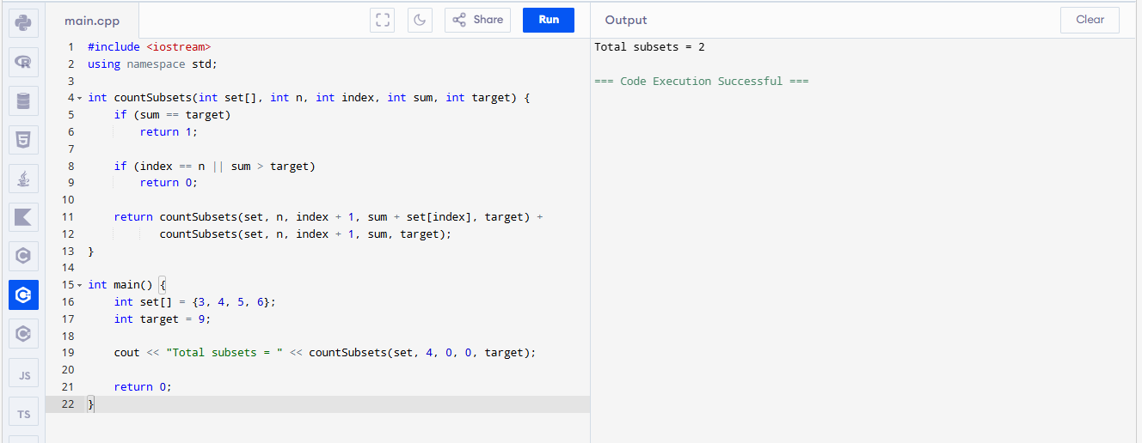
6. Write a C++ program where:
- User enters size of set
- User enters set elements
- User enters target sum
- Program prints all valid subsets
Example input:
Enter number of elements: 4
Enter elements: 3 4 5 6
Enter target sum: 9
Output:
Subset: 3 6
Subset: 4 5
Code:
#include <iostream>
using namespace std;

void subsetSum(int set[], int subset[], int n, int size, int sum, int target, int index) {
if (sum == target) {
cout << "Subset: ";
for (int i = 0; i < size; i++)
cout << subset[i] << " ";
cout << endl;
return;
}

if (index == n || sum > target)
return;

subset[size] = set[index];
subsetSum(set, subset, n, size + 1, sum + set[index], target, index + 1);

subsetSum(set, subset, n, size, sum, target, index + 1);
}

int main() {
int n, target;

cout << "Enter number of elements: ";
cin >> n;

int set[20], subset[20];

cout << "Enter elements: ";
for (int i = 0; i < n; i++)
cin >> set[i];

cout << "Enter target sum: ";
cin >> target;

subsetSum(set, subset, n, 0, 0, target, 0);

return 0;
}
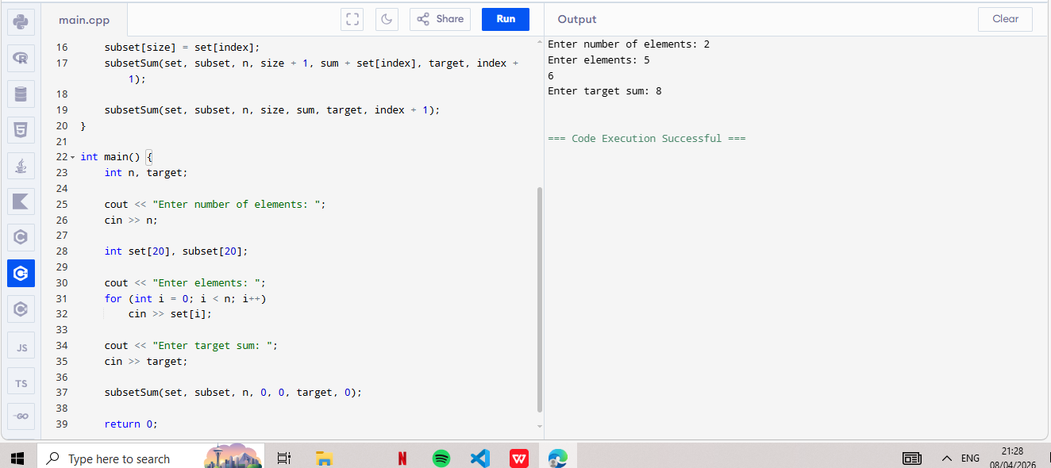
7. Modify the subset sum program so that the algorithm stops exploring branches where the sum exceeds the target.
If currentSum > target → stop exploring that branch.

This condition is already used in all codes:
if (sum > target)
return;
This is Backtracking Pruning → improves performance
Code:
#include <iostream>
using namespace std;

// Function to find subsets with pruning
void subsetSum(int set[], int subset[], int n, int size, int sum, int target, int index) {

// If target achieved → print subset
if (sum == target) {
cout << "Subset: ";
for (int i = 0; i < size; i++)
cout << subset[i] << " ";
cout << endl;
return;
}

// 🔥 Pruning condition (IMPORTANT)
if (sum > target)
return;

// If all elements processed
if (index == n)
return;

// Include current element
subset[size] = set[index];
subsetSum(set, subset, n, size + 1, sum + set[index], target, index + 1);

// Exclude current element
subsetSum(set, subset, n, size, sum, target, index + 1);
}

int main() {
int n, target;

cout << "Enter number of elements: ";
cin >> n;

int set[20], subset[20];

cout << "Enter elements: ";
for (int i = 0; i < n; i++)
cin >> set[i];

cout << "Enter target sum: ";
cin >> target;

cout << "\nSubsets with sum " << target << " are:\n";

subsetSum(set, subset, n, 0, 0, target, 0);

return 0;
}
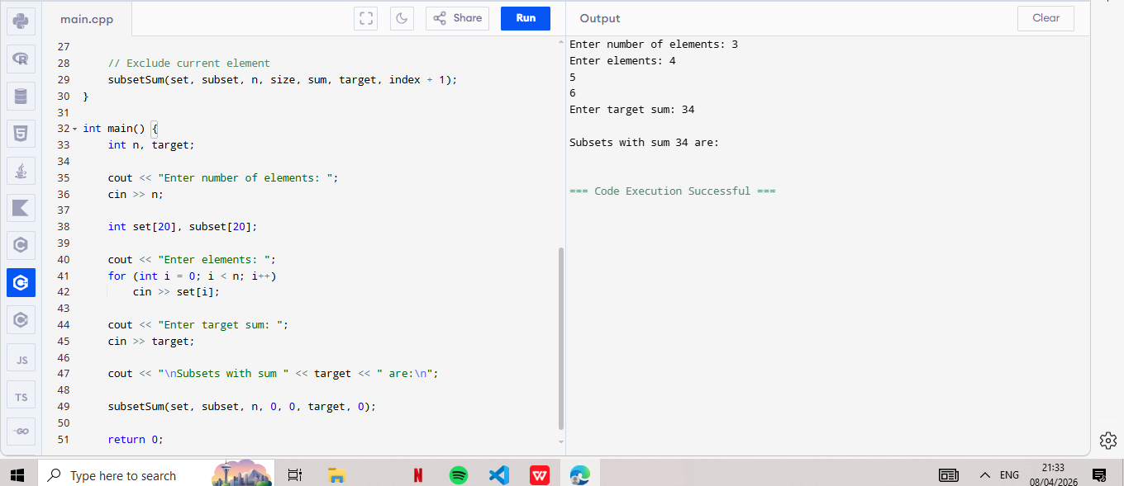

CODE (All-in-One Solution)
✔ User input
✔ Print all subsets
✔ Check existence
✔ Print one subset
✔ Count subsets
#include <iostream>
using namespace std;

int count = 0;
bool foundOne = false;

// Backtracking Function
void subsetSum(int set[], int subset[], int n, int size, int sum, int target, int index) {

// If target achieved
if (sum == target) {
cout << "Subset: ";
for (int i = 0; i < size; i++)
cout << subset[i] << " ";
cout << endl;

count++;

if (!foundOne) {
cout << "One Subset Found: ";
for (int i = 0; i < size; i++)
cout << subset[i] << " ";
cout << endl;
foundOne = true;
}
return;
}

// Stop conditions (Pruning)
if (index == n || sum > target)
return;

// Include current element
subset[size] = set[index];
subsetSum(set, subset, n, size + 1, sum + set[index], target, index + 1);

// Exclude current element
subsetSum(set, subset, n, size, sum, target, index + 1);
}

int main() {
int n, target;

cout << "Enter number of elements: ";
cin >> n;

int set[20], subset[20];

cout << "Enter elements: ";
for (int i = 0; i < n; i++)
cin >> set[i];

cout << "Enter target sum: ";
cin >> target;

cout << "\n--- All Valid Subsets ---\n";
subsetSum(set, subset, n, 0, 0, target, 0);

// Final Results
if (count > 0)
cout << "\nSubset with given sum exists.\n";
else
cout << "\nNo subset found.\n";

cout << "Total subsets = " << count << endl;

return 0;
}





